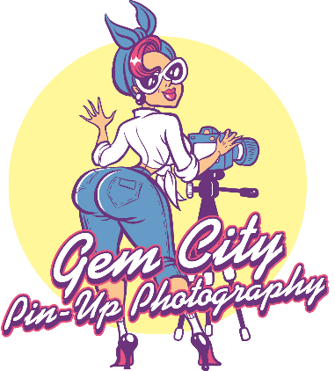

Thank You for your interest for in Gem City Pin Up Photography. Here a few Questions and Answers to help explain the process fully. We strive to make your experience not only fun, but something you will remember for life.

Do You Offer Make and Hair Services?
Yes, we do have stylist that are available on a limited schedule to assist with Make Up and Hair. Our stylist work with the in the studio as an independent artist. Stylist schedules will be noted on our booking page. Make sure to check the options when booking.
***Stylist Pricing is reflected in the package pricing, but are subject to change at any time.

What do I Wear?
While we do have a large wardrobe collection you are welcome to use. It is suggested to plan your wardrobe ahead. This assures the wardrobe fits properly the day of your session. Make sure you have proper under garments. If you use studio supplied wardrobe, please be cautious as pieces are often vintage or high end.

Where are you located?
Dayton, OH. We are in a private 1000sq foot studio space. The studio is in a large warehouse environment located on the second floor, requiring you to take stairs unless you are disabled. Our physical address is:
400 Linden Ave
Dayton, OH 45403
What is the difference between Edits and Retouched Edits?

When reading the descriptions with photographers it can get very confusing when you see the word edit. What is an edit? An edit is simply just adding a filter and adjusting lighting. A Retouched Edit is when the photographer fixes noticeable flaws and does skin smoothing and other small enhancements. This is a very timely process. This is one of the things that Gem City has strict standards on. Each package is listed with the style of images you will receive in your private gallery.

** Please note editing is subjective. We will not make you look like your favorite celebrity, we will make you look like the best you. If you have specific things you would like edited or not edited please address this before your session.

Do You Ever Do Location Shoots?

Absolutely!! If you would like a personal stylized shoot at a location of your choosing, we would love to accommodate you. This could be your own home, public area, garage. Please note some locations require a photographer’s permit. This cost will be passed on to the client and must be paid upfront along with the deposit.

Travel Fee’s of $.50 a mile will be added if your location is further than 25 miles from our studio location. Gas is not cheap!!!

How do I receive my images?

For standard sessions you will receive a link to private gallery to download your images, along with your print release. The gallery web site offers printing service to make thing easy, but we do not require you to print via the host gallery site. Feel free to print where ever. Please make sure to read you print release for details on your images. Gem City Pin Up Photography does not allow editing of finished images unless expressed in writing. Gem City Pin Photography retains all copyrights to all images.

How do I Book My Session?

We offer a simple process. Head to our booking site and find the date and time that works for you (please note Make Up and Hair services will only be available on select days, this will be easily identifiable when booking).
Here is the link to book your session. https://sagenda.net/Frontend/5c2ce80400a8204914baaa46?retrieveFromCookies=False

I Booked my Session, Now What?

You will receive a follow up email that has directions to the studio, info about your session and instructions on the next step, we ask that you confirm you received the info. Once we receive the confirmation, you will receive an invoice via PayPal to pay your deposit. Deposits must be paid with in 48 hours of invoice sent. If invoice is not paid, your spot will be added back to the calendar.

How do I prepare the day of my session?

First and for most RELAX. This is about having fun. To prepare, do all the prep you need the day before. Have your wardrobe pressed and ready, have all your accessories ready. If you are choosing to style yourself, get started early. We all know those days our hair has a mind of its own. If you are having your make up and hair done, as strange as this sounds, do not wash your hair the day of, even maybe 2 days before. Trust us, the more natural “Body” your hair has the better the style will be. Make sure to shower the day of, shave your legs, you know pamper yourself. The more confident and proud you are when you walk through the studio doors, the more that will shine through in your images.

Why Should I pick Gem City Pin Up Photography?

Our staff has years of experience with Pinup culture and style. We have personal experience with Pinup Modeling, styling and all things vintage. We will guide you with one on one posing, teach some quick tips and tricks that you can take with you to help make any future pictures look better. (We all love a good trick to look thinner).

Thanks for Considering Gem City Pin Up Photography,

Kimmi Lynn
Owner

